On Being Equal: The Co-First Author Phenomenon
Research in the 21st century is characterized by an increase in multidisciplinary studies, involving groups from all around the globe collaborating to show a wider picture of the topic in question, each lab putting on the table its specific expertise. This path is appreciated by funding agencies, journal editors and referees. One of the things directly affected by such collaborations is the crediting of publication's contributors, specifically, the first / last author listing, which are the places of the publication's leading scientists.
Ehimare Akhabue and Ebbing Lautenbach have recently reviewed the "Equally Credited Authors" or ECA trend, and reported a trend of increased percentage of leading journals' publications, which denote equal contribution of the first or/and last authors (sometime denoting up to five ECA's). It can be well anticipated that this trend will increase in time together with the competition for academic positions, and that the "paper counter" will have a central influence in the decision to accept or reject a potential tenure track candidate.

The problem
Earning credit is a basic human need and it meets most people at their ego level. Thus, author's order of appearance in publications is the source of many conflicts and disputes in and outside the lab. The first and last places, being the most prestigious positions, can be the source of even more intense possessiveness feelings. In many cases the decision to add a co-first author is taken at early stages of data gathering and manuscript preparation, such that the "original" first author is well aware of it and have accepted this change (and will usually remain the first listed).
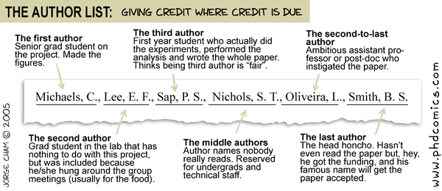
In most cases co-first authorship is conceived following scenarios such as:
- Combined intra-lab work - Sometimes two independent studies can be combined into a more complete manuscript, which, in many cases, may increase the chances for a higher impact factor publication. Problems usually arise when it is not clear which of the students has contributed more to the reported work, making it easier to assign the first and second co-first position to both. Worse situations occur when the PI makes the decision without discussing it with the contributors, and both are unaware of it until the manuscript is fully written and at the brink of submission/publications.
- Combined expertise of different labs - Co-first authorship is considered when two or more labs can't expect to publish their work without the methodologies and expertise of each other, and thus need to share the lead scientist position. Problems arise when PIs don't discuss and agree on the credit distribution at the inception of collaboration, leaving the void to be filled by students potentially skirmishing over the first author position.
- Lead student leaves the lab before completion/submission of the paper - In such case, another student needs to complete the work, handle any potential revisions, and revise the manuscript as required. Problems can arise if the ex-lab student is listed second (whether due to politics or due to work volume following a revision session).

The perception and use of co-first authorship
Authorship and order of authors appearance is a major issue in Academia, especially in science-related fields. Co-first authoring is even more debated and complicated, getting lengthy discussions in forums, blogs and even articles (read also here and here). Two main debates dominate this issue the first being how equal contribution can be granted when just one name can be cited first. The second debate, and not less important, is whether the two/three equal contributors can rearrange the order of authors' appearance when citing their paper in their CVs, such that each will appear first on his CV (they are equal, so why not??).
I will start this part off by saying that I perceive the co-first authorship conduct as a trustworthy act, which is exactly how science should be in the first place. Scientists should not "abuse" this option with a less-than-equal contribution only to compensate unlucky students in the lab that need leading-author publications for their career or PhD completion. The co-first authorship should be used only when a real equally combined and complementing work is required for publication. Of course, this is a qualitative rather than quantitative measure, and it is the responsibility of the PI(s) to maintain proper use of the above co-first author conduct. For PIs, collaborations, in many cases, are the most efficient research and lab management practice, since, as I stated before, collaboration means combining the students' expertise and labor to generate better science/stories/publications.
Of course, the single first place can be occupied by only a single name, and usually only this first name is cited in other papers' body, thus leading to much frustration. Furthermore, there is a common belief that the asterisk in many cases doesn't really reflect real equity between author number one and the other authors. Unfortunately, there is no way to change the way other researchers and scientists perceive the state of co-first authors, and it is unlikely that the citation system (e.g. PubMed) will be change to reflect co-first authors contribution.
The aforementioned issues laid the foundations of the controversial "swapping of co-first authors" order in CVs and presentations. It seems that not so few students or even senior scientists see citations as a flexible system that can be bent and twisted based on their needs, so long as they are justified by the asterisk. This is an unethical conduct, since citations should be strictly maintained as they appear in the scientific literature. Furthermore, many PIs have commented in forums that applicants that have swapped co-first authors in their CVs are treated differently, or their application is ignored altogether. If a candidate has twisted the citation for his own benefits, maybe he will also bend the results of his experiments to fit a certain claim they are pursuing? Ethical behavior is the cornerstone of scientific conduct and should be kept strict at all times.
P.S.1 - I myself act as the second co-first author on a publication; I am maintaining the exact citation (complemented with asterisks) in posters, presentations and in my CV/LinkedIn profile.
P.S.2 - The "Publications" section on LinkedIn, unfortunately, does not list authors according to their citation order. It is the responsibility of each user to list all authors of a paper in the correct order in the "Description" field. For example: "Correct authors order: Name 1, Name 2, etc."
Are you a co-first author? Have an opinion about this blog post? Share your thoughts with us and the readers!

